

**WEIGHT AND SIZE REQUIREMENTS**

**WEIGHT:** the total weight of an EMS item should not exceed 30 kg. However the value of the weight may be less, depending on the requirements of **the country of destination**.

**SIZE:** minimum – 229х324mm;

maximum – any dimension – 1500mm, wherein the sum of the length and the largest circumference measured in any direction other than the length – 3000mm.

**Recommendations for measurement of EMS items**

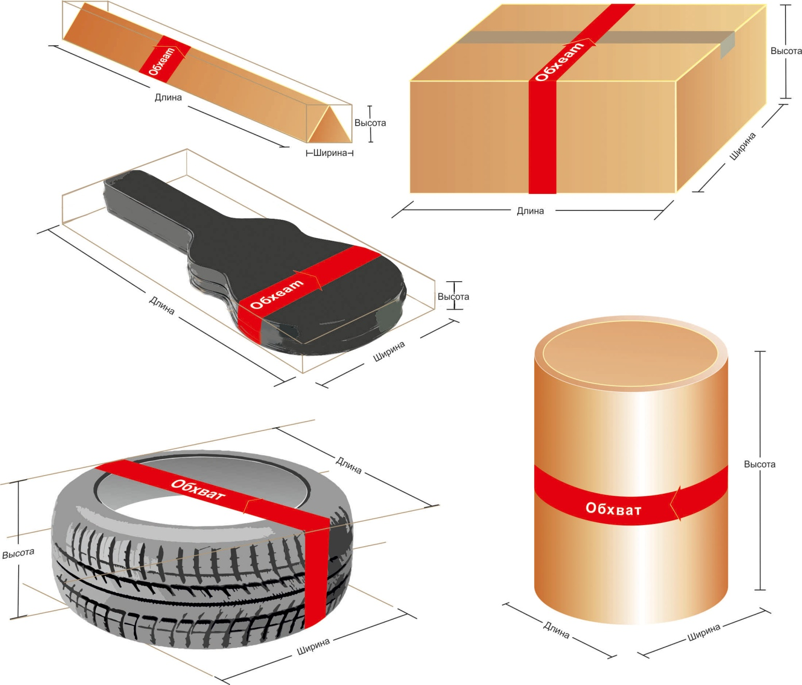

maximum 3000mm = length + 2*(height + width) or girth + length,

**It should be considered that**

the maximum size of one of the dimensions (length, height, width, girth) = 1500mm.